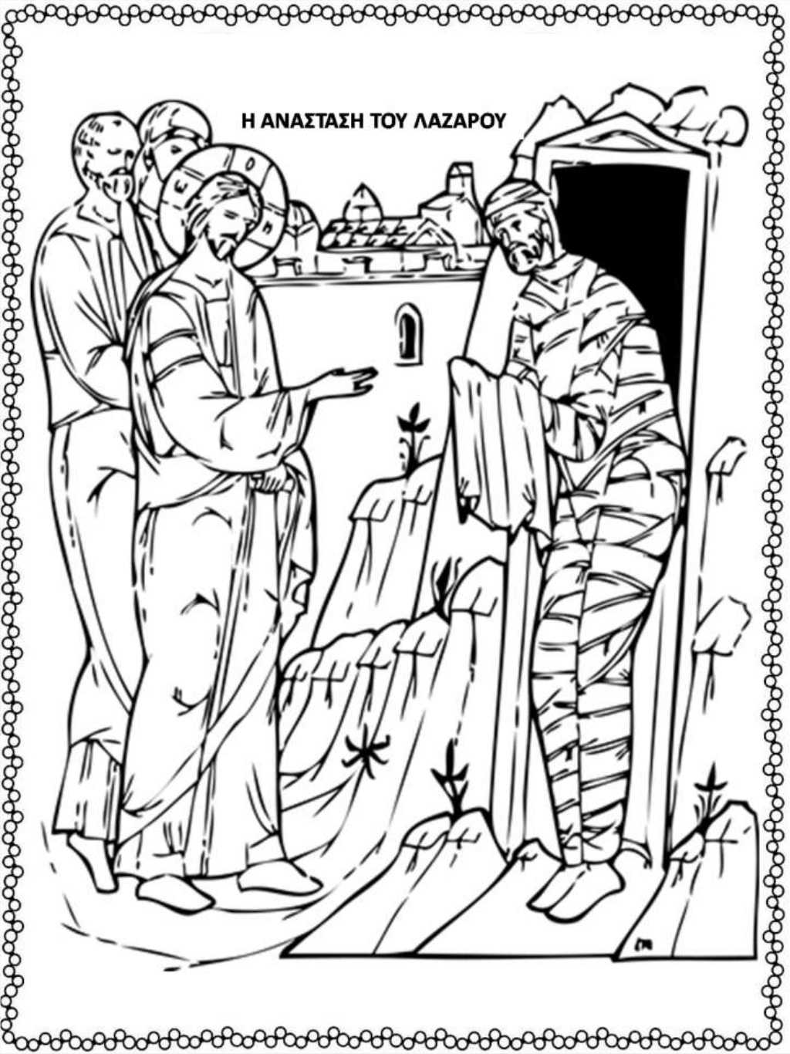

https://www.slideshare.net/epapadi/httpblogsschgrgoma-httpblogsschgrepapadi-91976467

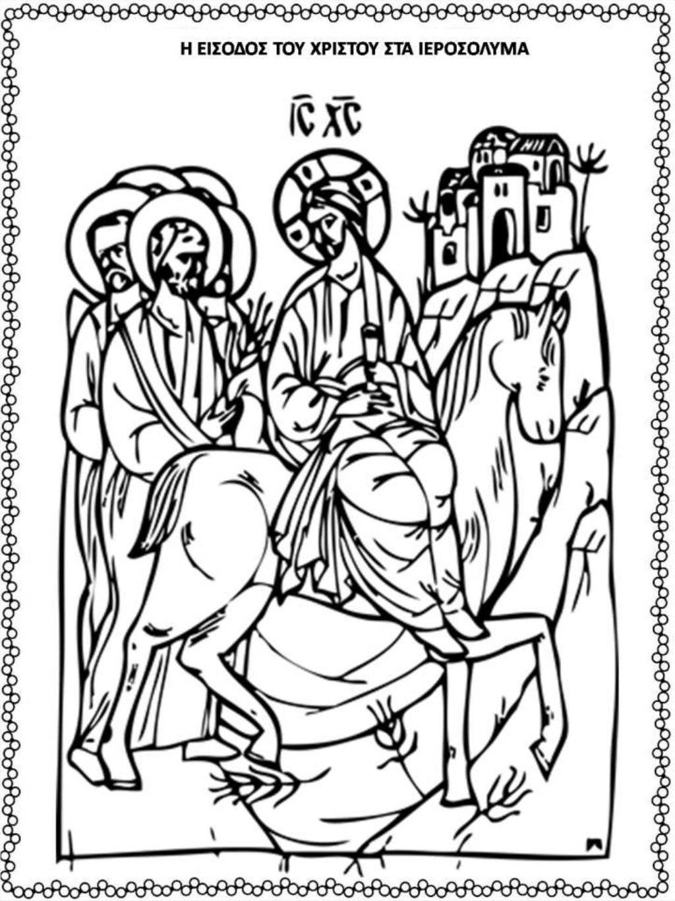

https://www.slideshare.net/epapadi/httpblogsschgrgoma-httpblogsschgrepapadi-91976467

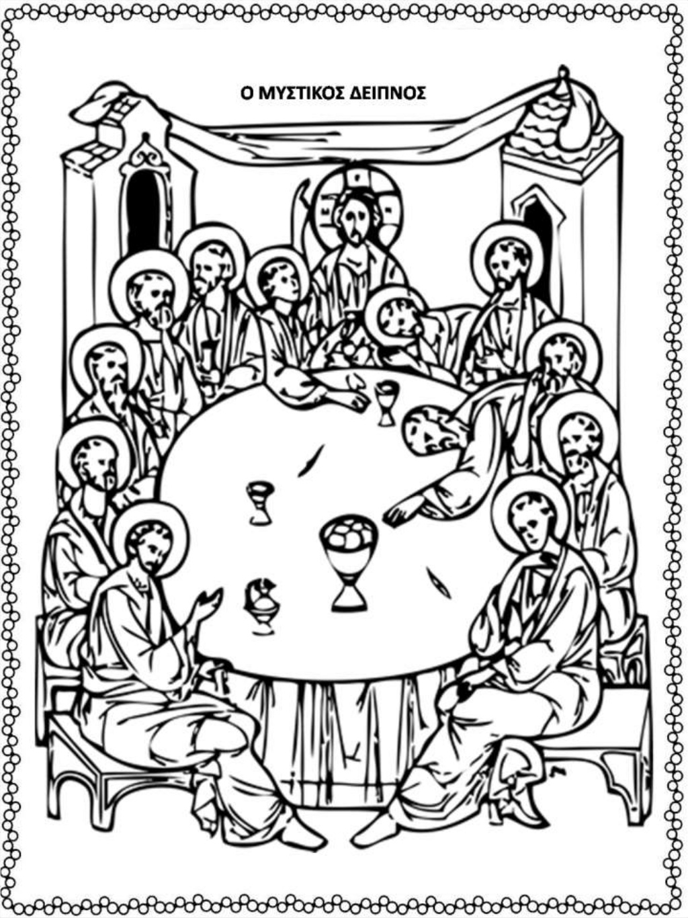
https://www.slideshare.net/epapadi/httpblogsschgrgoma-httpblogsschgrepapadi-91976467
https://www.slideshare.net/epapadi/httpblogsschgrgoma-httpblogsschgrepapadi-91976467

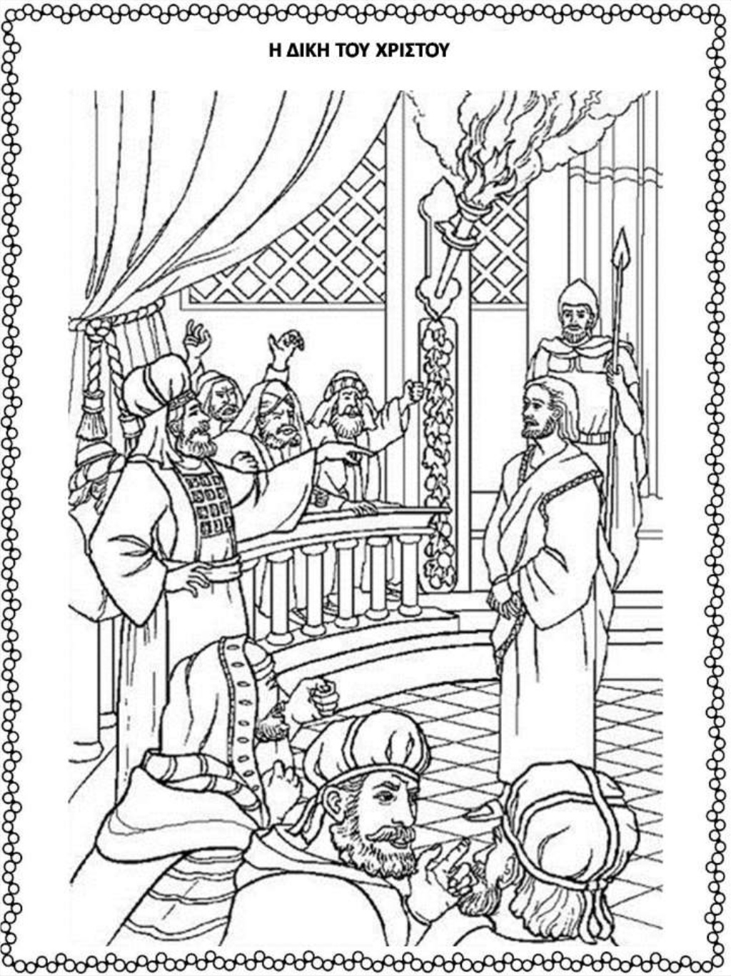

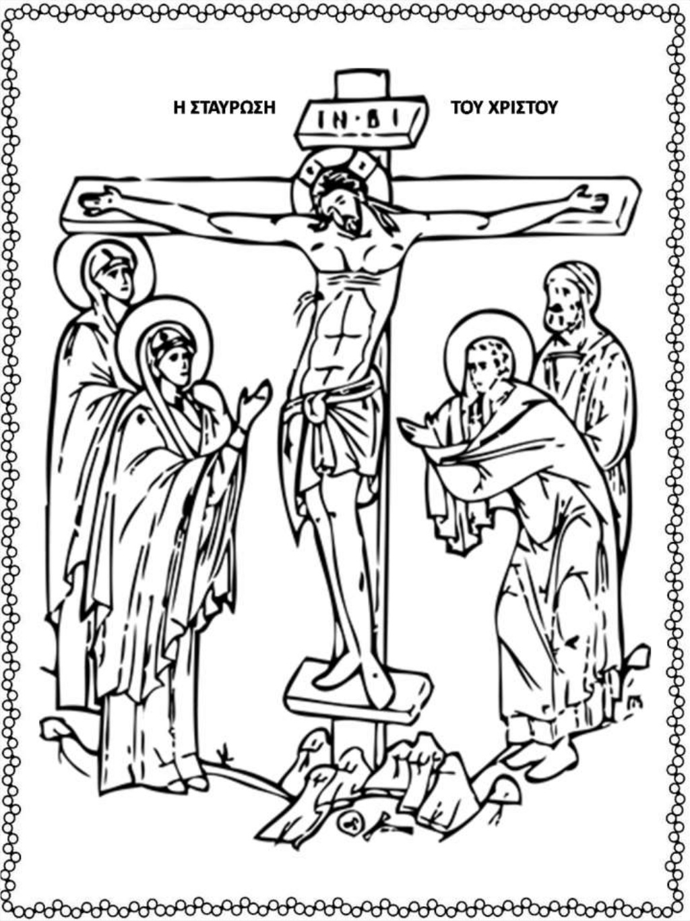

https://www.slideshare.net/epapadi/httpblogsschgrgoma-httpblogsschgrepapadi-91976467

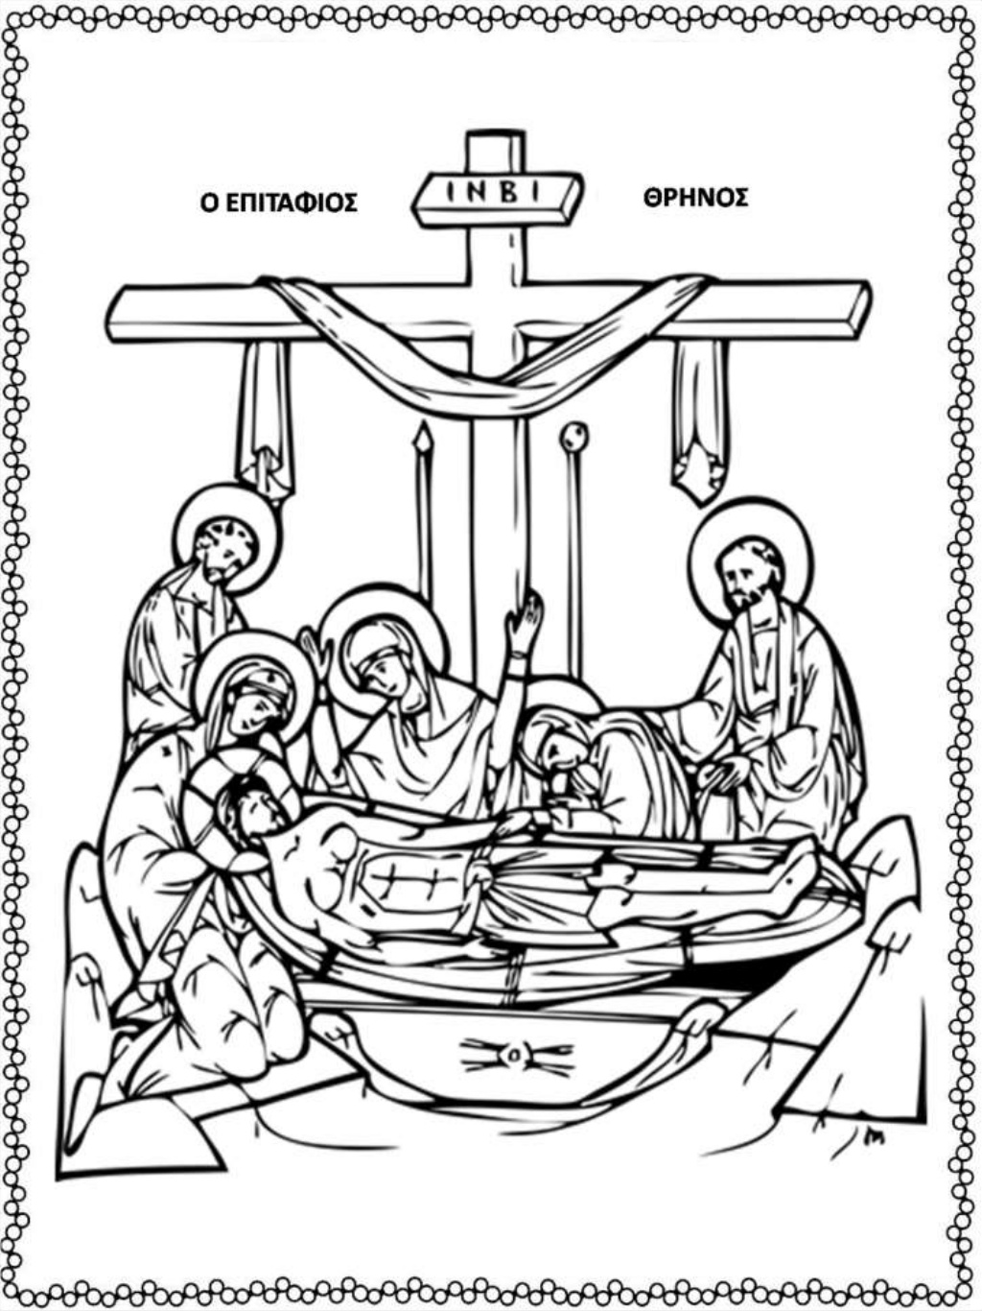

https://www.slideshare.net/epapadi/httpblogsschgrgoma-httpblogsschgrepapadi-91976467

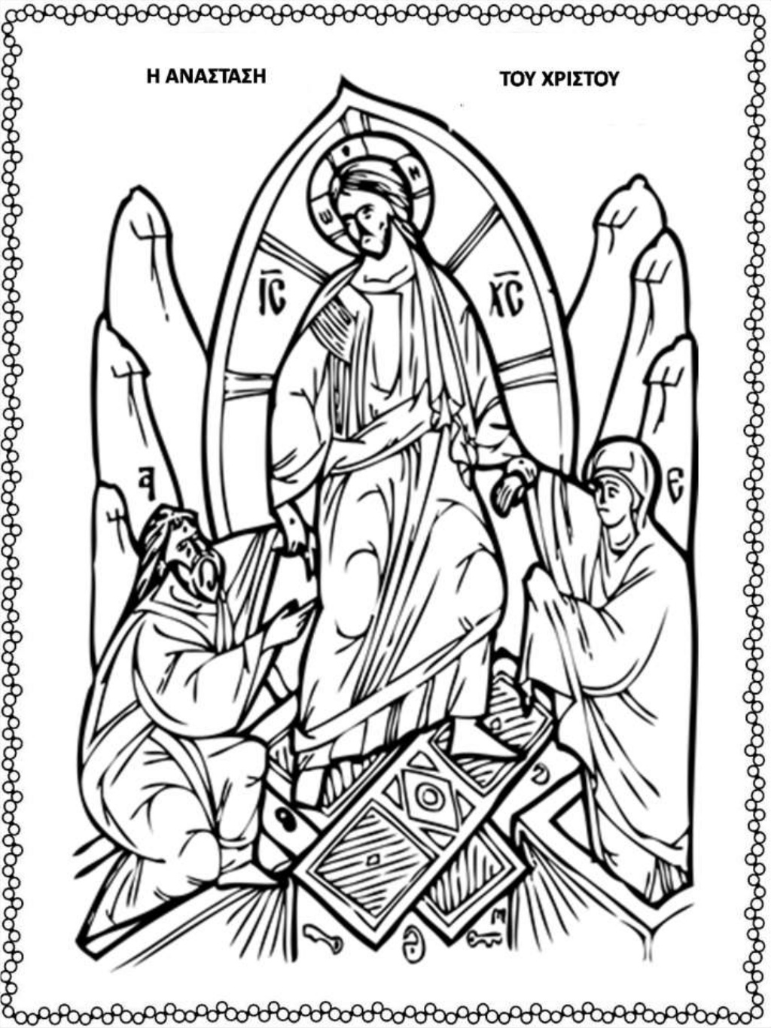
https://www.slideshare.net/epapadi/httpblogsschgrgoma-httpblogsschgrepapadi-91976467

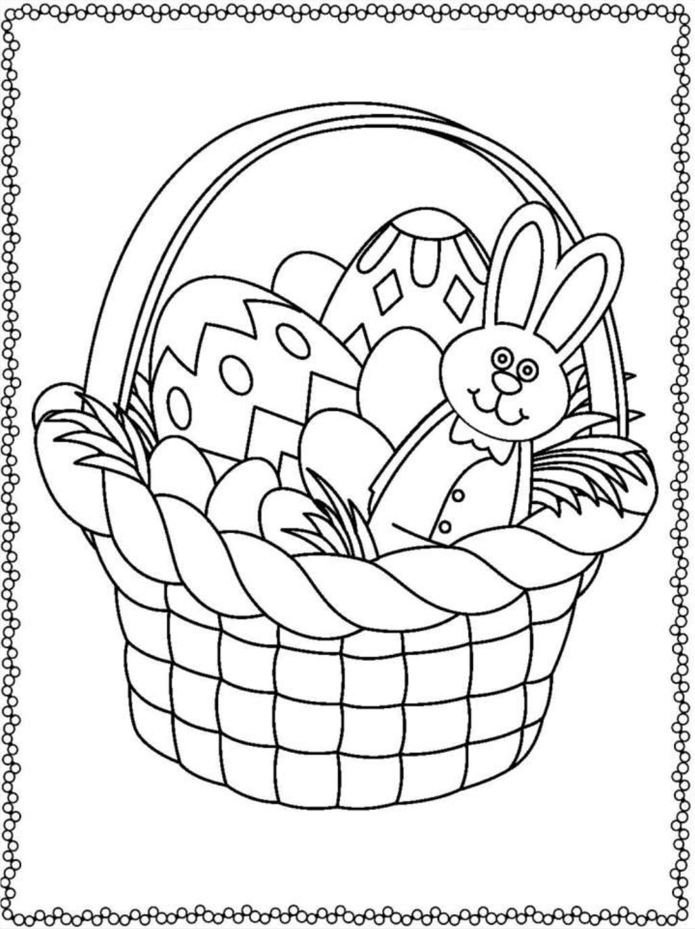

https://www.slideshare.net/epapadi/httpblogsschgrgoma-httpblogsschgrepapadi-91976467





